TASK REPORT

Responsive Flipkart-Style
Product Card
Created using HTML and CSS with a mobile viewport configuration

1. Objective
The objective of this task was to design and implement a professional, Flipkart-inspired product card using HTML and CSS. The card presents key shopping information in a compact layout and includes a viewport meta tag to support appropriate rendering on mobile devices.

2. Tools and Technologies
- HTML5 — structures the product card and its content.
- CSS3 — styles the card, spacing, typography, colors, and layout.
- Meta viewport tag — sets the layout viewport to the device width and the initial zoom level.
- Visual Studio Code and a web browser — suitable tools for editing and testing the page.

3. Implementation Summary
- Created the project files: Created index.html for the page structure and style.css for visual styling.
- Added responsive metadata: Included <meta name="viewport" content="width=device-width, initial-scale=1.0"> in the HTML head.
- Built the product information area: Added the product image, product title, description, rating, price, original price, discount, and delivery offer.
- Styled the card: Used a white card background, rounded corners, subtle shadow, spacing, and clear typography to create an e-commerce appearance.
- Prepared mobile styling: Used flexible width rules and a maximum card width, with a small-screen media query to adjust padding.

4. Final Output
The screenshot below shows the product card as rendered in a desktop browser. It includes a headphone image, product title and description, customer rating, pricing and discount information, a free-shipping offer, and a Buy Now button.
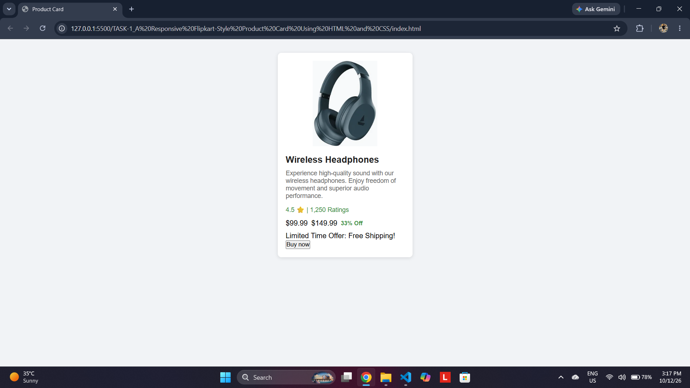
Figure 1. Final product card displayed in the browser.

5. Result and Observations
- The product information is grouped into a single, readable card.
- The viewport metadata is present to help mobile browsers render the page at the device width.
- The screenshot confirms the card renders in a desktop browser; mobile responsiveness should additionally be verified using browser device emulation or a physical phone.

6. Conclusion
The task demonstrates the use of semantic HTML and CSS to build a simple e-commerce product card inspired by Flipkart. The viewport meta tag and responsive CSS provide a foundation for mobile-friendly presentation. Further improvements could include a real product image, a responsive grid for multiple products, and functional cart or purchase interactions.

